**Simple Storage Service(S3):**

* S3 is storage service in AWS which is used to store the unlimited amount of data like doc,text,video,audio,xml files etc and retrieve the data.
* The data will be stored in the form of objects.
* S3 is a global service so we can access the data from anywhere in s3.
* Data will be highly available ,secure in s3.

**Buckets:**

* Buckets are nothing but a containers or folders for objects.
* We can store the objects inside the buckets.
* We can increate maximum 100 buckets per aws account.If we want we can increase the buckets limit but we need to take permission from AWS.

**Objects:**

* Objects are nothing but a files or folders inside the buckets.
* Size of file is from 0 bytes to 5 TB.

**How to access the data inside a file or object:**

* By default block the public access for all buckets and objects.
* We need to modify or enable the permissions.
* Open the bucket which we want to access and click on permissions tab.
* Uncheck or off the block all public access option.
* Edit the object ownership in which click on enable acls and save it.
* Click on Edit on access control list and select list,read permissions and save.
* Go to the objects sections and select file or object which file data we want to access.
* Go to actions and click on make public using acls.

Without allow all permissions whatever we have mentioned above.we can’t access the data inside a file.

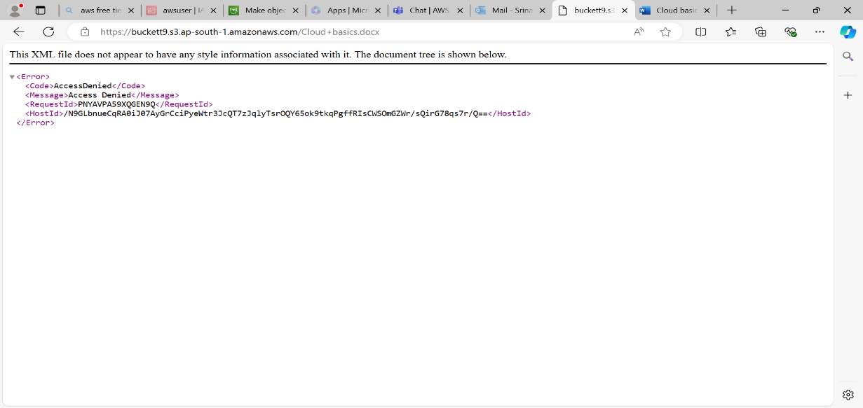

Allow or modify all permissions whatever we have mentioned above.we can access the data inside a file.

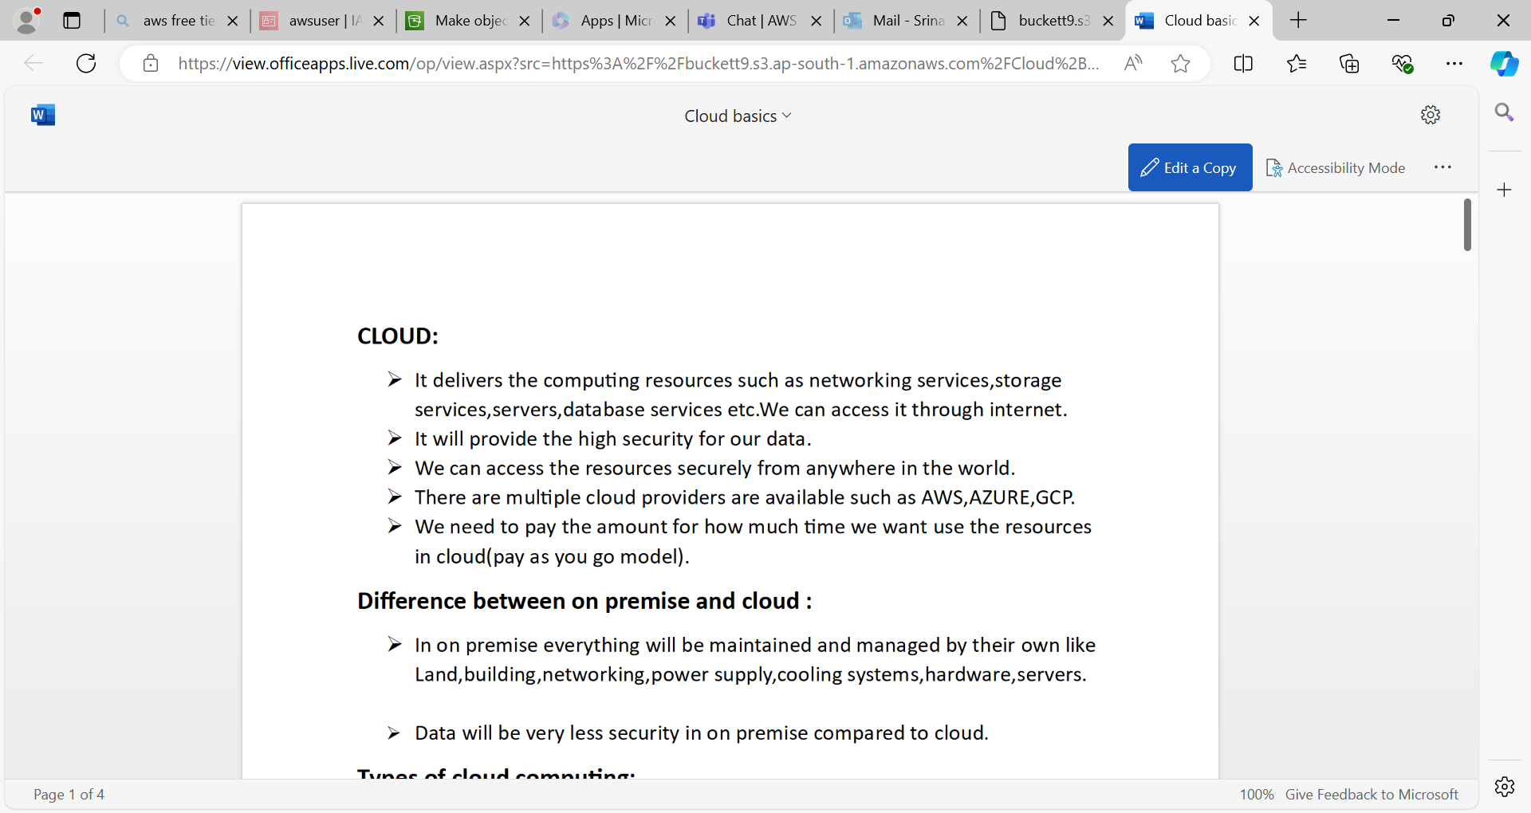

**Bucket policy:**

* Bucket policies are used to give the access permissions to all objects whatever objects inside a particular bucket we can access the data inside a file (instead of make the every object as public after uploading the object inside a bucket)
* We can create the bucket policy for particular bucket.

